CAPSTONE PROPOSAL: SET LIST MANAGER
10 November 2020

Overview:
I propose a web application in which users can create and save their own ordered lists of songs, integrating with the Genius API to retrieve and save those songs’ lyrics. Users will then be able to view those ordered lists and select songs for lyrics retrieval. I envision this app being used on multiple types of devices, but primarily on large mobile devices such as tablets, for setlist management and lyrics retrieval during musical performances.
Demographics:
My intended demographic is musicians, whether professionals or mere hobbyists.
Data source:
This app would use the Genius API to retrieve lyrics, possibly in conjunction with johnwmillr’s LyricsGenius package. This app will use the APISEEDS Lyrics API.
Database Schema:
This is my initial plan for my database schema:
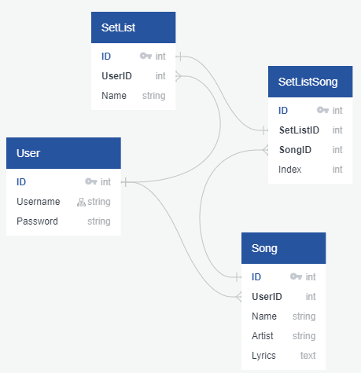
Potential API Issues:
One possible difficulty might be retrieving search results based on song titles and artist names, as in some cases there are multiple songs with the same or similar titles but different lyrics; it might also be difficult to handle typographical errors, special characters, or unusual syntax in song titles or artist names.
Sensitive Information:
The only sensitive information likely to be included here is passwords, which will be handled using bcrypt. It’s possible I’ll decide to include email addresses in the user registration, but at this point I don’t think that’s necessary.
Functionality:
Functionality will include user registration/login, setlist creation/reordering/other modification/deletion, song importing/creation (in the event that the song cannot be imported using Genius), song modification (at this point I plan on allowing modification of lyrics only), and deletion of users, songs, and setlists. Most importantly, the app will have a performance mode which will display a selected setlist in order and allow convenient switching between active songs, for the easy display of lyrics.
User Flow:
A typical user might reach the app, create an account, and begin importing songs, with the option to manually create songs if importing is impracticable. Once several songs are imported, the user might then organize them into a setlist and save that setlist. With a setlist made, the user might then open that setlist in performance mode, for convenient use during a performance or rehearsal. Once finished, the user might log out, with the option to log back in at a later time to reuse the saved songs or setlists.
Key Feature:
In addition to being a convenient way to use a database to manage songs, lyrics, and setlists, the main advantage of this app over something like a spreadsheet, an Access database, or a simple paper binder would be the performance mode, which presents the information saved in the database to the user in an extremely convenient fashion.
Stretch Goals:
If I can, I’d eventually like to add chord notation functionality, so the app would also be useful to instrumentalists, not just singers.

